COSMIC WATCH MUON DETECTOR
ANDROID APPLICATION FOR MUON DETECTOR PERIPHERAL
J.M. Ngo1 and J.M.K.C. Donev1
¹University of Calgary, Calgary, Alberta, Canada
john.ngo@uclagary.ca
An Undergraduate Level Submission
Abstract:
Often, scientific instruments are difficult to transport or use. By miniaturizing the instrument and streamlining the interface, experiments can be more easily done. The MIT ‘household level’ muon detector [1] is already miniaturized, but it requires a PC to provide power and log detection events, thus it remains difficult to use and transport. By creating an android application to interface with the detector, the PC can be substituted with an android phone, which further presents a streamlined user interface and real-time observation of detection events. As a proof of concept, two experiments were conducted – the first on the impact of time of day on detection counts, the second on varying heights and locations. The application will allow the detector to be deployed anywhere, under varying circumstances, and become easy enough to use, such as under high school experiment conditions.

Introduction
Muons are a fundamental particle of the lepton family [2], with a lifetime around 10⁻⁶ seconds, typically generated in the interaction of high energy particles with Earth’s upper atmosphere. These muons make up part of background ionizing radiation, which may need to be calibrated against when conducting experiments and are also evidence of Einstein’s theory of relativity [2].
The detector, built by Jordan Hanania [2] based on blueprints from MIT [1] is a small ‘household level’ system, approximately the size of a hat, which utilizes scintillators and photomultipliers to detect muons as electrical pulses within a range of accepted amplitudes [2]. An Arduino system logs these signals, then transfers this data as text through a USB port, which also provides the Arduino system with power. Originally, this USB port was meant to interface with a Python based PC program, which transferred this text into a text file whilst running.
The problem is that most PCs are large and difficult to transfer from place to place, preventing users from utilizing the otherwise small size and portability of the muon detector itself. Furthermore, the user interface of the python program is not friendly and did not allow for real-time data display or analysis. This paper goes over the Android application my team (including Celina Ma and Omar Qureshi) built to solve this problem and illustrates some ‘high-school level’ example experiments it can be used in.

Application and Application Development
Jordan Hanania previously built an Arduino-based muon detector which automatically received power via USB and sent detection event as text through the same port. From there, my team’s task under the guidance of Dr. Jason Donev was to create an android application to interface with the detector. The goal was to take USB text output and convert it into detection events and readings visible on a user interface simple enough for the interested layperson to utilize. This we did in Android Studio as part of our Software Engineering course, using agile methodologies, after which the project transitioned to a slower pace.
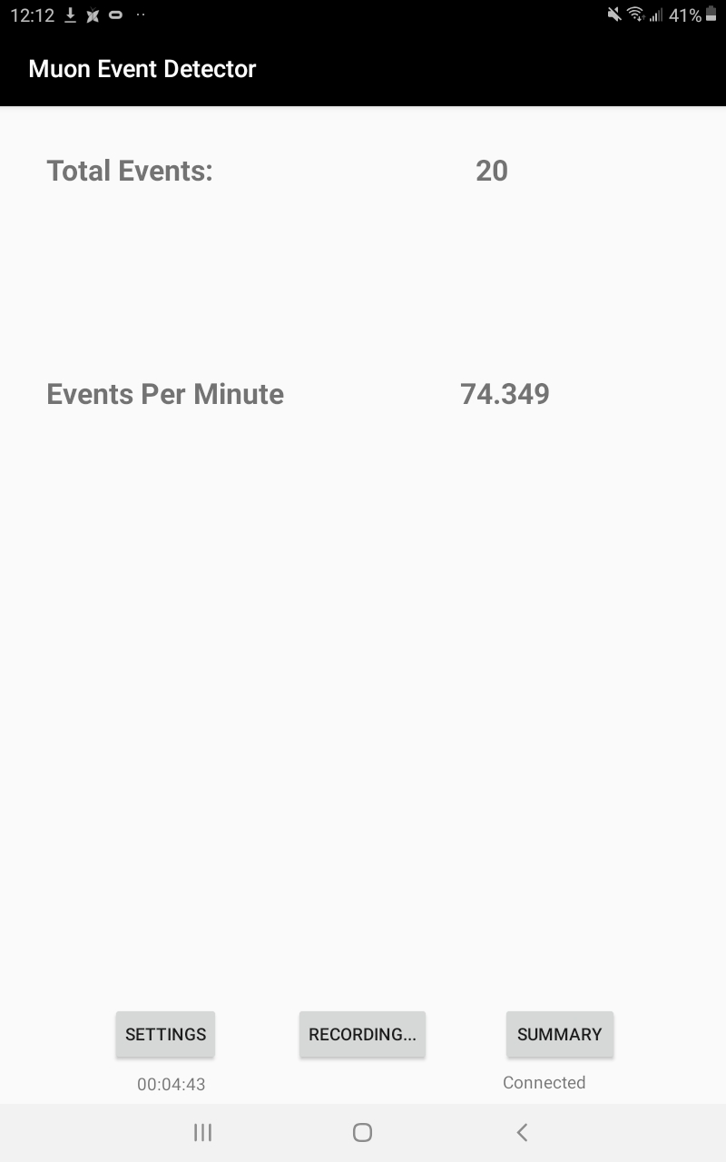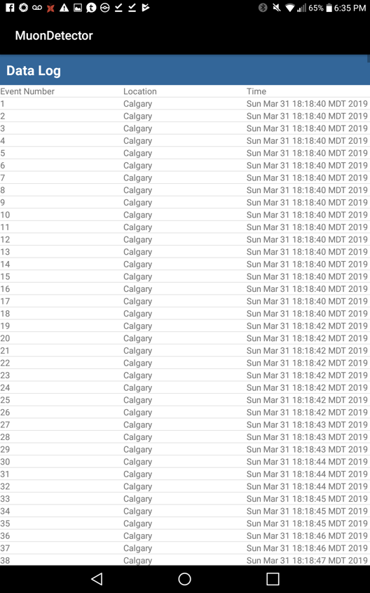

Figure 1 and 2: Recording Screen and Data Logging Screen

Interfacing and Use Features
Interfacing with the device and saving recorded data are the core features of this application. A simple popup confirms the peripheral is detected and connected, whilst the central button records and the settings button adjusts recording length. When the recording is finished, a CSV file containing information on each detection event recorded is saved to the device under the Cosmic Watch data folder, for out-of-application analysis.

Data Analysis Features
Another feature of the android application is real-time data analysis and comparison on the android device itself, without needing to transfer any data to the computer first. Currently, our implementation of such features is rudimentary, featuring only a log screen, but in the future, we plan to include tables and graphs, such as a graph of detection events over time, and so on.

Sample Experiments and Experiment Results
The sample experiments are simple due to the application, and suitable for high school students.

Experiment 1: Variation of muon counts by time of day
The solar wind is a constant stream of high-energy particles; perhaps the impact of the solar wind on Earth’s atmosphere may generate muons. If it does, then I would expect a difference between the number of muons generated during different times, especially between day and night.
To conduct this experiment, attach the muon detector to the Android device, start the application, ensure connection (via a popup and message on the bottom right), use settings to set the length of recordings, then record by hitting the central button. Whilst there is no feature to automatically record on a timer (yet), the application allows this experiment to be conducted anywhere.
In this sample experiment, five-minute recordings were taken from early afternoon on January 4th to early January 5th, 2020. The results are graphed below:
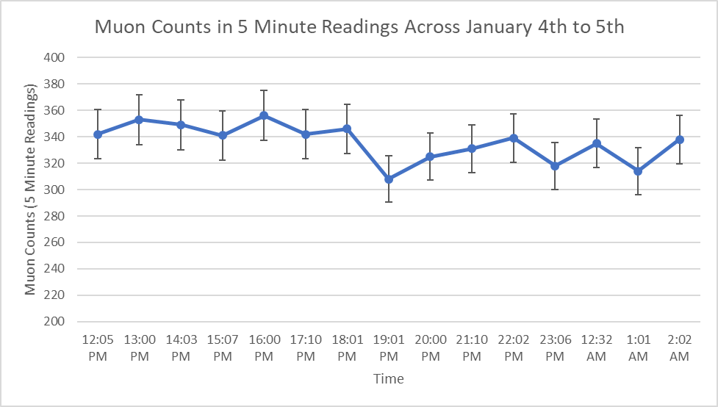

Figure 3: Muon Readings by Time Across January 4th to 5th, 2020
In the data, there is a two-part structure divided by the sudden drop around 19:01 pm, about 2 hours past the 17:00 pm sunset time in Calgary. Almost all variation remains within uncertainty. According to the weather data from the website Time and Date, around 6pm on January 4th the weather shifted from broken clouds to passing clouds, indicating increasing cloud cover [3].
It is possible the slightly lower equilibrium after 19:01 pm is due to cloud conditions changing, or due to the sun dipping behind the horizon, or both, but if so, the impact is marginal. This is best interpreted as a null result – the sun does not impact muon generation. This experiment demonstrates the utility of the user interface in the form of one button data recording, and data collection feature in the form of saved data analysed here.

Experiment 2: Impact of material cover on material counts
Mass blocks most forms of ionizing radiation, since the radiation could run into the mass and ionize the mass instead of whatever is behind it. Muons should be no different.
To investigate the impact of material cover, the instructions are identical to the prior experiment, only that you will want a variety of locations with differing amounts of mass above the detector. Here, I utilized a tall, multi-story building, the UCalgary Earth Sciences Building, as a proxy for mass between the cosmic muons above, and the detector below. Readings were taken across ten floors across 1.5 hours, on a cloudy February 13th, 2020. The results are as follows:

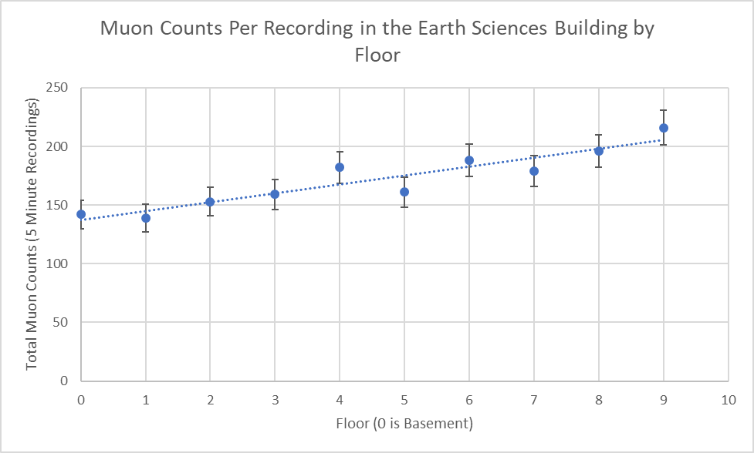

Figure 4: Muon Readings by Floor in the Earth Sciences Building on February 13th, 2020
I can see there is an upward trend with the floor level and the muon counts per reading. In theory, higher floors mean less floors above, and so less mass obstructing the muons from impacting the detector. This theory is confirmed with the experiment results. Overall, this sample data confirms the relationship between mass blocking the cosmic muons and the number of muons detected, and further confirms the cosmic muons are coming from above, rather than sideways, since if they came sideways, there should be no difference amongst the upper floors.
This experiment demonstrates the portability of the setup. Imagine lugging along a full laptop along with the hat-sized detector up ten floors, then setting up the devices for a five-minute reading before heading to the next floor. Now imagine doing the same with a smartphone and the detector. The latter is significantly easier, and was done in 1.5 hours between classes, with the primary difficulty being locating acceptable spots to place the detector.

Conclusion
Based off prior work by Jason Hanania [2], my team has constructed a streamlined Android application user interface for his ‘household level’ muon detector. This app allows the device to be utilized with a more portable Android based device such as a smartphone, and thus maximizing the portability of its already small design. The application can power the detector, record and display live data, save recorded data, as well as conduct limited data analysis.
With this portability and ease of use, simple ‘high school’ level experiments can be easily conducted. Two simple experiments, the first utilizing the application interface over time, the second utilizing the application across various positions, demonstrate the utility of this new interface. In the first experiment, the data collection and ease of use features allowed a 12+ hour experiment to be conducted with minimal hassle. In the second experiment, the portability of the detector allowed for an easy demonstration of the relationship between the amount of mass above the detector and its total detection rates. Both these experiments are suitable for the interested layman with access to the detector and application to conduct.
Further development of the application in the user interface and data analysis features will improve the overall utility of the application. It is our hope that the application can spur on additional research with the muon detector or be utilized by laypeople such as high school students in simple research projects to improve understanding on cosmic muons.

Acknowledgements
Dr. Zahra Shakeri provided us with the opportunity to pursue this project as part of her software engineering course. Jordan Hanania, a former undergraduate student at the U of C, created the muon detector [2] with guidance from blueprints by S.N. Axani, J.M. Conrad, and C. Kirby[1].

References
[] S. Axani, J. Conrad, and C .Kirby, “The Desktop Muon Detector: A simple, physics-motivated machine- and electronics-shop project for university students,". Available: https://arxiv.org/pdf/1801.03029.pdf
[] J. Hanania, “Development of a desktop muon detector,”. University of Calgary 2016
[3] Time and Date AS. (2020). Past Weather in Calgary, Alberta, Canada - January 2020. Retrieved January 19, 2020, from https://www.timeanddate.com/weather/canada/calgary/historic?month=1&year=2020

